Algebra 1: Unit 13, Lesson 8

- Carlton and Frankie are working together on a problem. They are asked to create an expression which represents the amount of good muffins baked when $4$ muffins per batch are burned. Each batch contains $35$ muffins, and $c$ represents the number of batches baked.
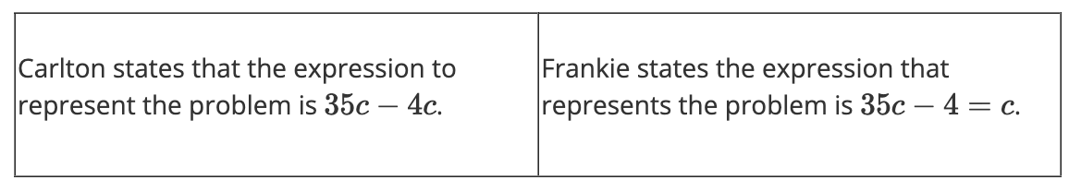
Who is correct and why?
Carlton, because $35c$ represents the number of muffins baked and $4c$ is the total number of muffins burned. This is an expression.

- John is setting up a playground for his children. It takes him $h$ hours to set up the playground. After $2\frac{5}{8}$ hours of setting up the playground, it begins to rain. Write an expression that represents the amount of time that John has left to set up the playground.

$$h-2\frac{5}{8}$$

- Consider the expression $178{\left(\frac{1}{2}\right)}^{x}$. Which part of the expression represents the coefficient?

$$178$$

